# **Name: Abdurrahman Qureshi**

# **Roll No: 242466**

Practical No: 5

Date Of Performance: 11/08/2025

Aim: Download n install NMap tool on windows and use it with different options to scan open ports, pingscan, TCP scan, UDP scan

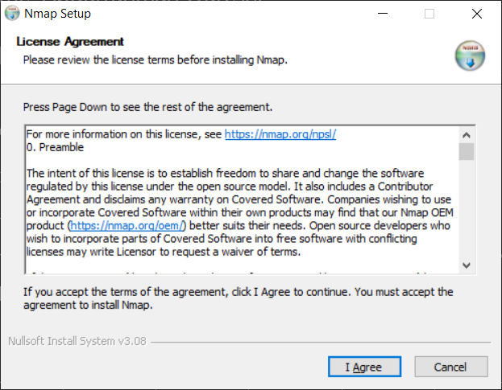

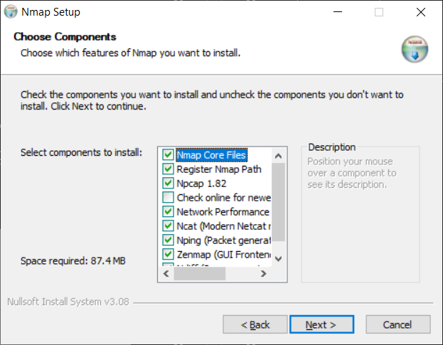

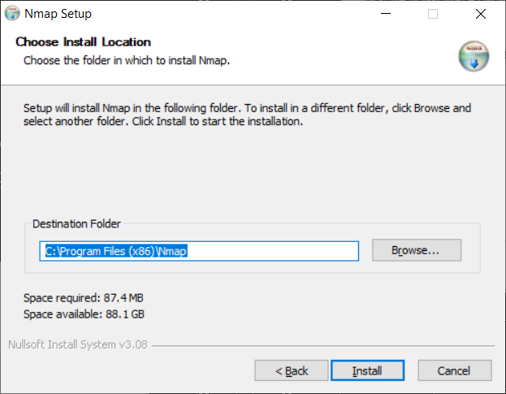12

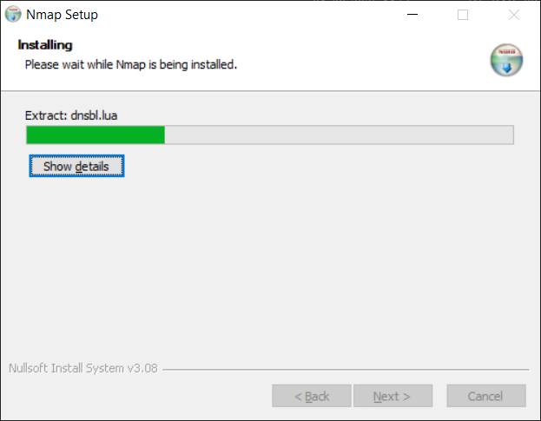

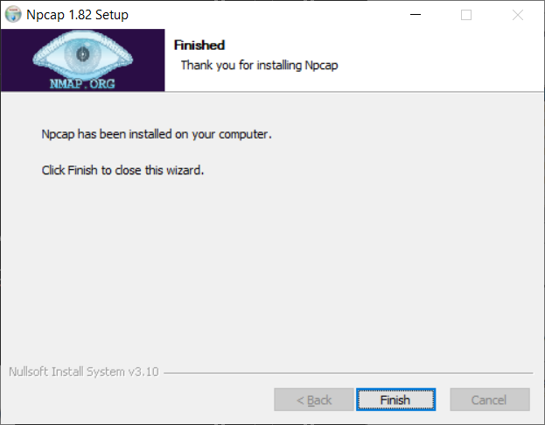

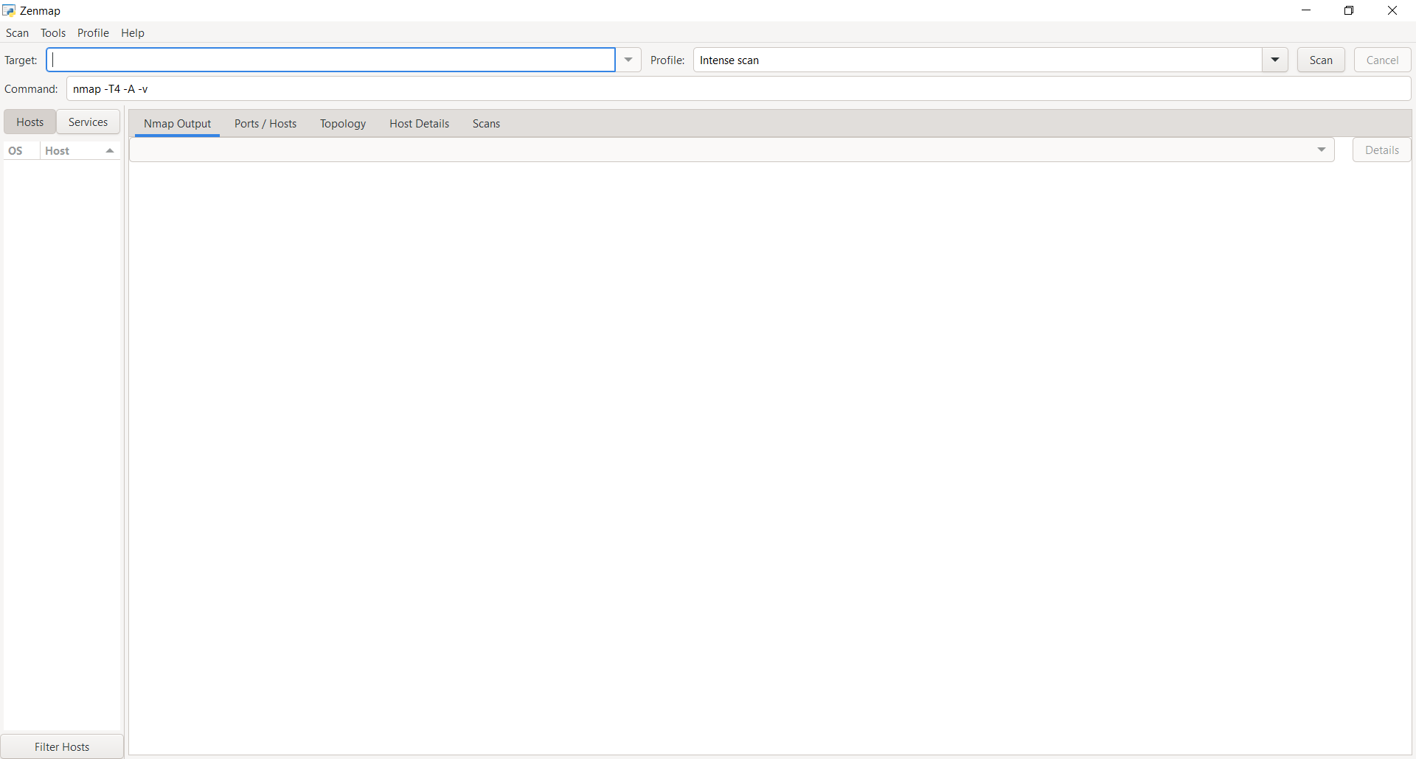

TCP

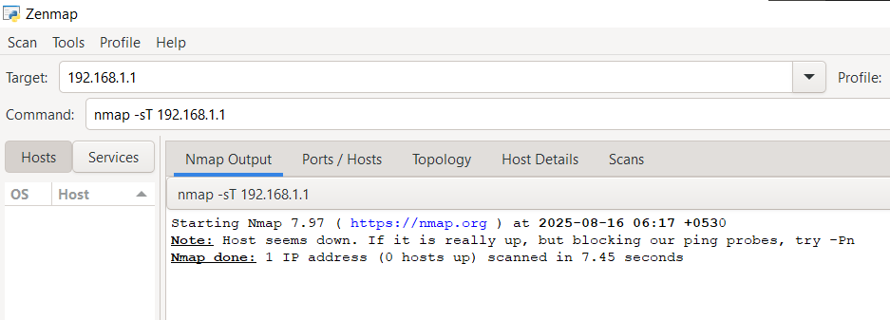

UDP

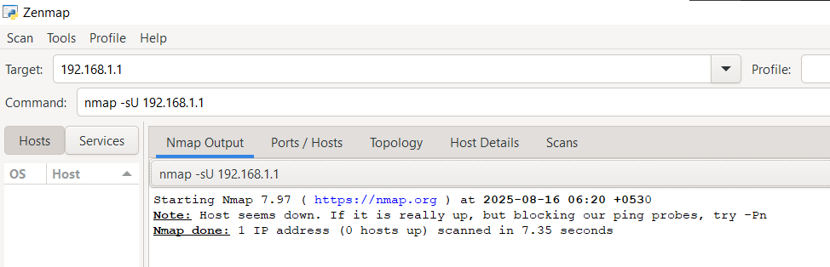

Basic Nmap Scan against IP or host

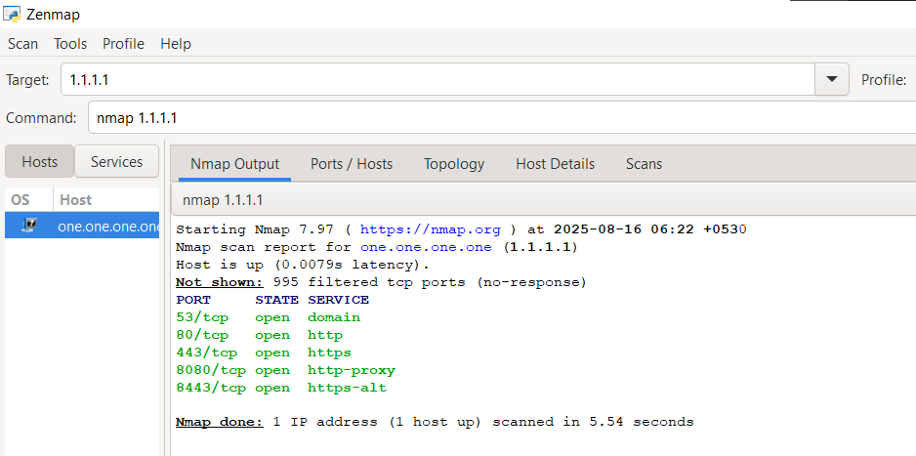

Scan specific ports or scan entire port ranges on a local or remote server

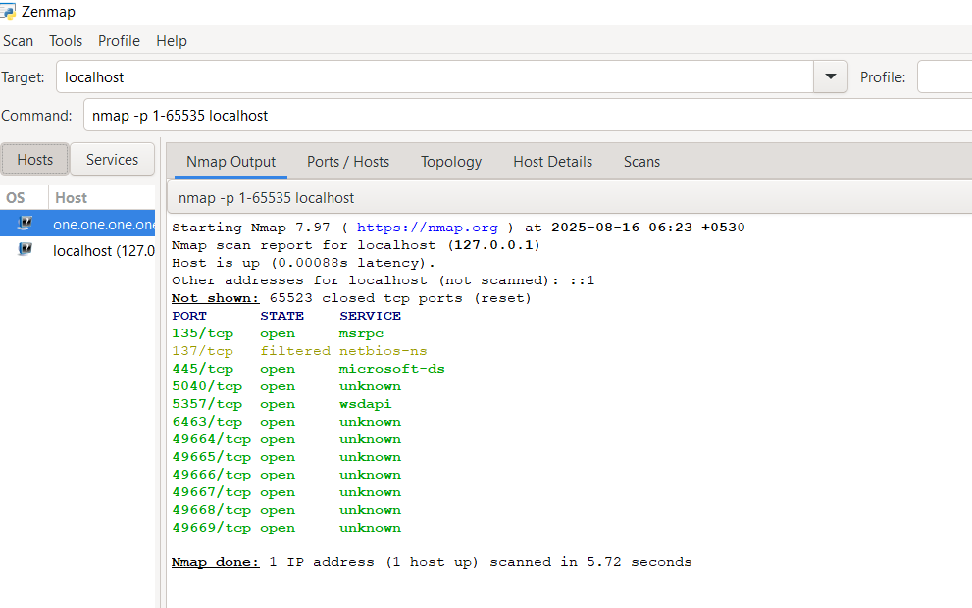

Scannign Mulitple IP addresses

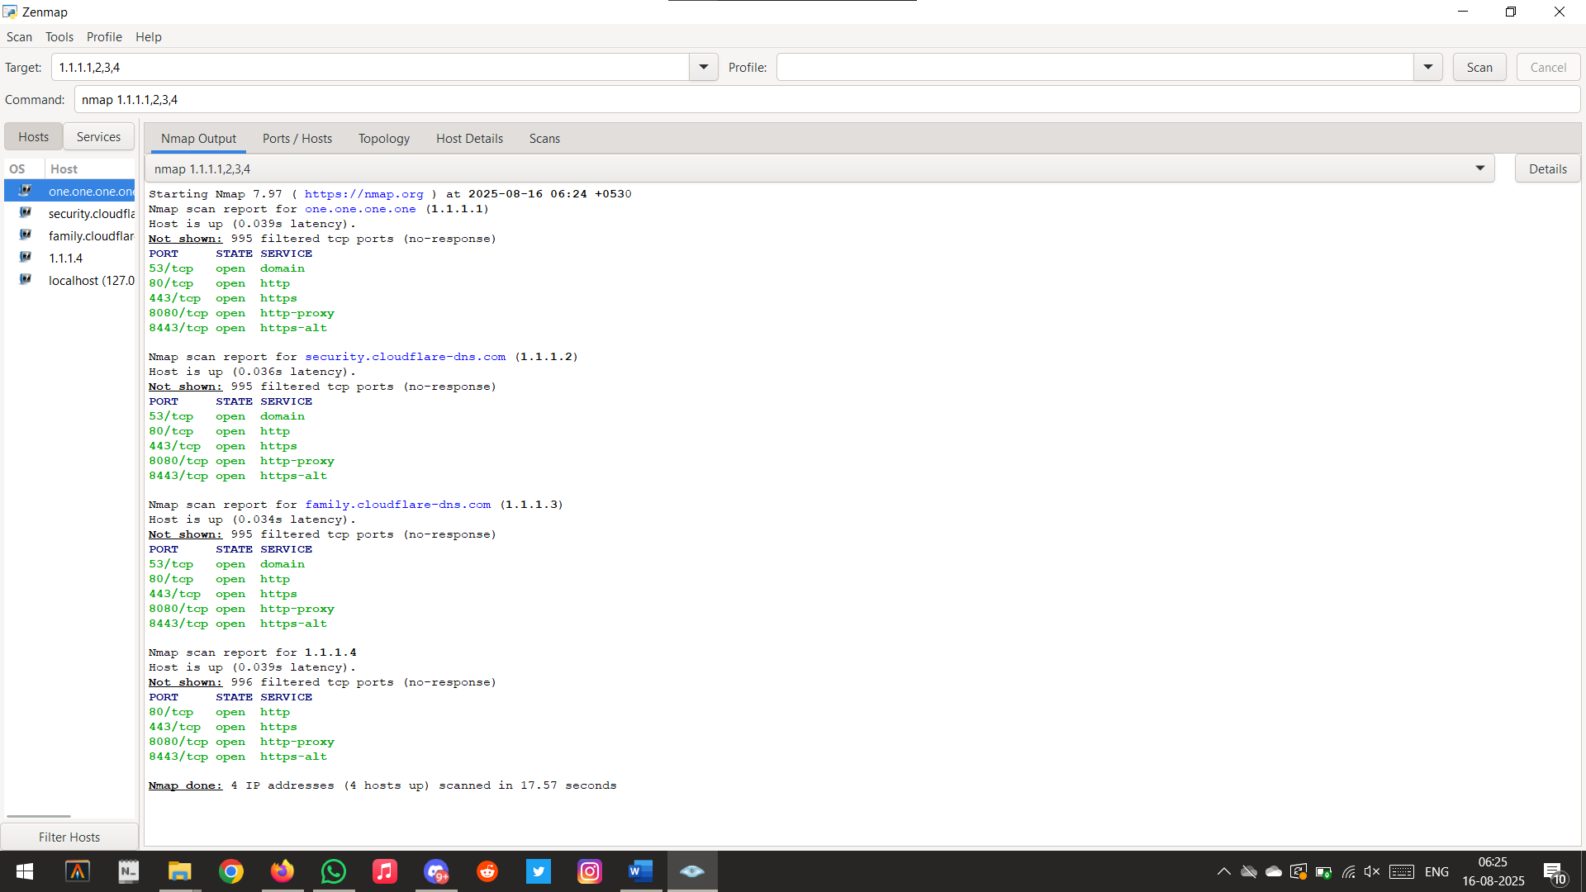

Scanning Services

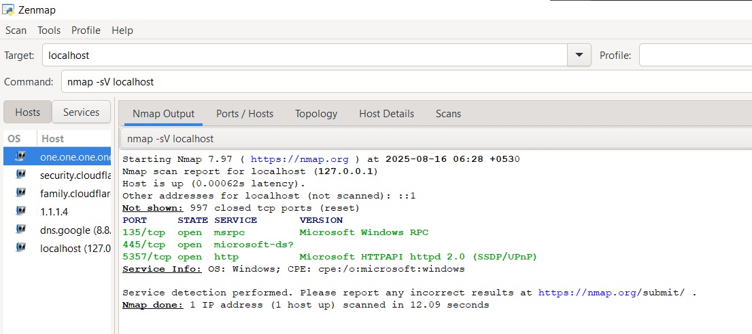

Fast Scanning top 100 ports

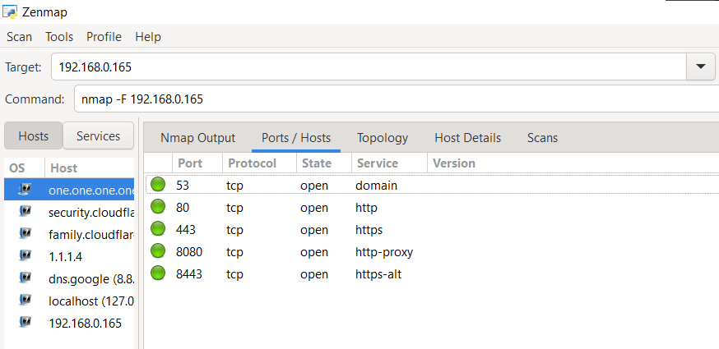

|  |  |  |  |  |  |
| --- | --- | --- | --- | --- | --- |
| Performance  (7M) | Journal  (3M) | Lab Ethics  (2M) | Attendance  (3M) | Total  (15M) | Faculty Signature |
|  |  |  |  |  |  |